NAME: AALAGIYA KEESAN VITTHALBHAI
CLASS: SYBCA DIV: 4 SEMESTER: 4
ROLL NO: 1
SUBJECT: .NET Technology
___________________________________________________
1. Develop a Windows Application to Collect and Display Personal Details.
Ans:-
-: Screenshot :-
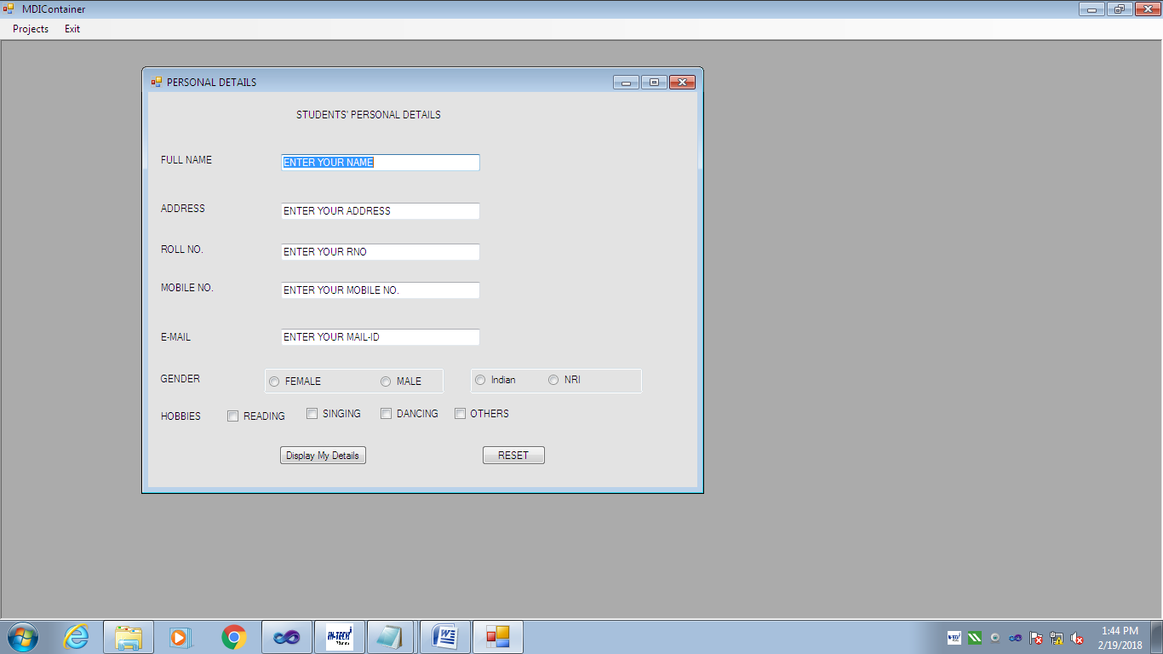
-: Coding :-
Public Class frmPerDetails
Private Sub rbFemale_CheckedChanged(ByVal sender As System.Object, ByVal e As System.EventArgs) Handles rbFemale.CheckedChanged
If rbFemale.Checked = True Then
picMorF.ImageLocation = "C:\Users\Public\Pictures\Sample Pictures\Koala.jpg"
Else
picMorF.ImageLocation = "C:\Users\Public\Pictures\Sample Pictures\Penguins.jpg"
End If
End Sub
Private Sub btnDisplay_Click(ByVal sender As System.Object, ByVal e As System.EventArgs) Handles btnDisplay.Click
Dim strname, stradd, strmail, strgender, strH As String
Dim rno As Integer
Dim mno As Double
strname = txtName.Text
stradd = txtAddress.Text
strmail = txtEMail.Text
rno = txtRno.Text
mno = txtMno.Text
If rbFemale.Checked = True Then
strgender = "FEMALE"
Else
strgender = "MALE"
End If
If chkbReading.Checked = True Then
strH = chkbReading.Text & vbNewLine
End If
If chkbSinging.Checked = True Then
strH += chkbSinging.Text & vbNewLine
End If
If chkbDancing.Checked = True Then
strH += chkbDancing.Text & vbNewLine
End If
If chkbOthers.Checked = True Then
strH += chkbOthers.Text & vbNewLine
End If
MsgBox("YOUR PERSONAL DETAILS ARE " & vbNewLine & "YOUR NAME IS : " & strname & vbNewLine & "YOU ARE FROM : " & stradd & vbNewLine & "YOUR ROLLNO IS : " & rno & vbNewLine & "YOUR MOBILE NO IS : " & mno & vbNewLine & "YOUR EMAIL IS : " & strmail & vbNewLine & "YOU ARE : " & strgender & vbNewLine & "YOUR HOBBIES ARE :" & vbNewLine & strH)
End Sub
Private Sub Button1_Click(ByVal sender As System.Object, ByVal e As System.EventArgs) Handles Button1.Click
txtName.Text = ""
txtAddress.Text = ""
txtEMail.Text = ""
txtMno.Text = ""
txtRno.Text = ""
If rbFemale.Checked Then
rbFemale.Checked = False
Else
rbMale.Checked = False
End If
If rbIndian.Checked Then
rbIndian.Checked = False
Else
rbNRI.Checked = False
End If
chkbDancing.Checked = False
chkbOthers.Checked = False
chkbReading.Checked = False
chkbSinging.Checked = False
End Sub
End Class
----------------------------------------------- THE END------------------------------------------------------------------

