NAME: AALAGIYA KEESAN VITTHALBHAI
CLASS: TYBCA DIV: 4 SEMESTER: 5
ROLL NO: 1
SUBJECT: .NET Technology
___________________________________________________
1. Registration page with validation.
Ans:-
Design

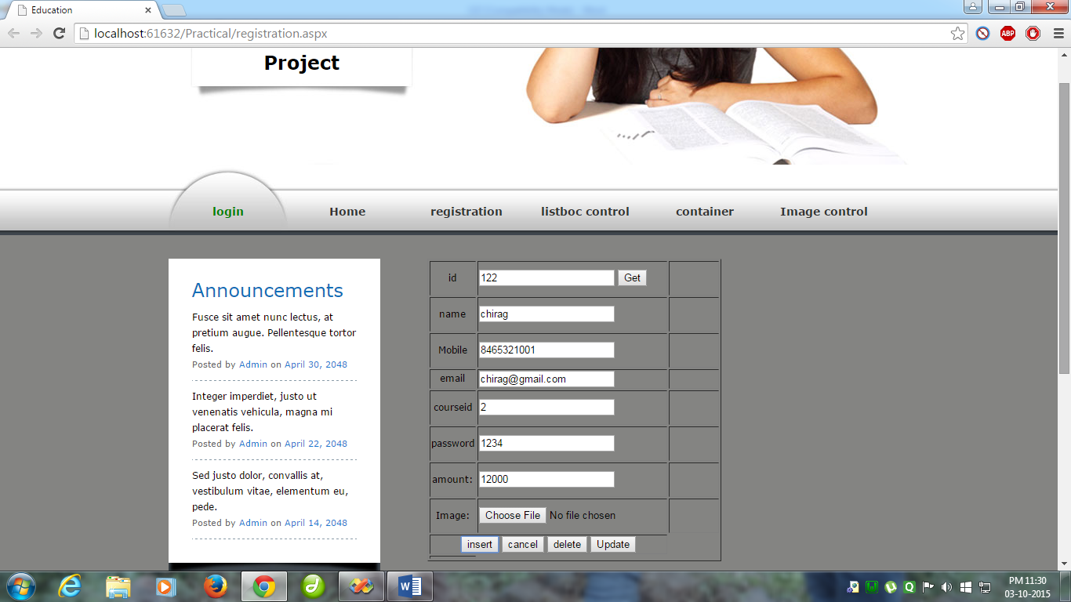
Code Behind

<%@PageLanguage="VB"AutoEventWireup="false"CodeFile="registration.aspx.vb"Inherits="registration"MasterPageFile="~/mymaster.master"%>

<asp:ContentID="Content1"ContentPlaceHolderID="ContentPlaceHolder1"Runat="Server">
<div>
<tableid="Table2"runat="server"border="1"width="100">
<tr>
<tdalign="center"style="width: 115px">
id</td>
<td>
<asp:TextBoxID="txtid"runat="server"></asp:TextBox>
<asp:ButtonID="btnget"runat="server"Text="Get"/>
</td>
<td>
<asp:RequiredFieldValidatorID="v1"runat="server"ControlToValidate="txtid"ErrorMessage="enter name">enter
name</asp:RequiredFieldValidator></td>
</tr>
<tr>
<tdalign="center"style="width: 115px">
name</td>
<td>
<asp:TextBoxID="txtname"runat="server"></asp:TextBox>
</td>
<td>
<asp:RequiredFieldValidatorID="v2"runat="server"ControlToValidate="txtname"ErrorMessage="enter email">enter
email</asp:RequiredFieldValidator>
</td>
</tr>
<tr>
<tdalign="center"style="width: 115px">
<asp:LabelID="label3"runat="server">Mobile</asp:Label>
</td>
<td>
<asp:TextBoxID="txtmobile"runat="server"></asp:TextBox></td>
<td>
<asp:RequiredFieldValidatorID="v3"runat="server"ControlToValidate="txtmobile"
ErrorMessage="enter mobile">enter mobile</asp:RequiredFieldValidator>
</td>
</tr>
<tr>
<tdalign="center"style="width: 115px">
email</td>
<td>
<asp:TextBoxID="txtemail"runat="server"></asp:TextBox></td>
<td>
<asp:RequiredFieldValidatorID="v4"runat="server"ControlToValidate="txtemail"ErrorMessage="enter city">enter
city </asp:RequiredFieldValidator>
</td>
</tr>
<tr>
<tdalign="center"style="width: 115px">
courseid</td>
<td>
<asp:TextBoxID="txtcourseid"runat="server"></asp:TextBox></td>
<td>
<asp:RequiredFieldValidatorID="v5"runat="server"ControlToValidate="txtcourseid"
ErrorMessage="enter username">enter username</asp:RequiredFieldValidator>
</td>
</tr>
<tr>
<tdalign="center"style="width: 115px">
password</td>
<td>
<asp:TextBoxID="txtpass"runat="server"></asp:TextBox></td>
<td>
<asp:RequiredFieldValidatorID="RequiredFieldValidator1"runat="server"ControlToValidate="txtcourseid"
ErrorMessage="enter username">enter username</asp:RequiredFieldValidator>
</td>
</tr>

<tr>
<tdalign="center"style="width: 115px">
amount:</td>
<td>
<asp:TextBoxID="txtamount"runat="server"></asp:TextBox></td>
<td>
<asp:RequiredFieldValidatorID="RequiredFieldValidator2"runat="server"ControlToValidate="txtamount"
ErrorMessage="enter amount">enter username</asp:RequiredFieldValidator>
</td>
</tr>

<tr>
<tdalign="center"style="width: 115px">
Image:</td>
<td>
<asp:FileUploadID="fileupload"runat="server"/>
</td>
<td>
<asp:RequiredFieldValidatorID="RequiredFieldValidator3"runat="server"ControlToValidate="txtamount"
ErrorMessage="enter amount">enter username</asp:RequiredFieldValidator>
</td>
</tr>

<tr>
<tdalign="center"colspan="2">
<asp:ButtonID="btn1"runat="server"Text="insert"/>
<asp:ButtonID="btn2"runat="server"CausesValidation="false"Text="cancel"/>
<asp:ButtonID="btndelete"runat="server"Text="delete"/>
<asp:ButtonID="Btnupdate"runat="server"Text="Update"/>
</td>
</tr>
<tr>
<tdstyle="width: 115px">
<asp:ValidationSummaryID="valisummary"runat="server"ShowSummary="true"Width="100px"/>
</td>
</tr>
</table>

</div>
<asp:LabelID="lblstatus"runat="server"Width="341px"></asp:Label><br/>
<br/>

<asp:GridViewID="GridView1"runat="server"BackColor="White"BorderColor="#3366CC"BorderStyle="None"BorderWidth="1px"CellPadding="4">
<FooterStyleBackColor="#99CCCC"ForeColor="#003399"/>
<RowStyleBackColor="White"ForeColor="#003399"/>
<SelectedRowStyleBackColor="#009999"Font-Bold="True"ForeColor="#CCFF99"/>
<PagerStyleBackColor="#99CCCC"ForeColor="#003399"HorizontalAlign="Left"/>
<HeaderStyleBackColor="#003399"Font-Bold="True"ForeColor="#CCCCFF"/>
</asp:GridView>

</asp:Content>

Code
Imports MySql.Data.mysqlclient
Imports System.Data

PartialClass registration
Inherits System.Web.UI.Page
Dim str AsString = ConfigurationManager.ConnectionStrings("practical").ToString
Dim cn AsNew MySqlConnection(str)

ProtectedSub Page_Load(ByVal sender AsObject, ByVal e As System.EventArgs) HandlesMe.Load

Try
Dim cmd AsNew MySqlCommand("select * from studinfo;", cn)
Dim da AsNew MySqlDataAdapter(cmd)
Dim ds AsNew DataSet
da.Fill(ds, "studinfo")
GridView1.DataSource = ds.Tables("studinfo")
GridView1.DataBind()
Catch ex As Exception
MsgBox("please enter proper coading")
EndTry

EndSub

ProtectedSub btndelete_Click(ByVal sender AsObject, ByVal e As System.EventArgs) Handles btndelete.Click
Try
Dim cmd AsNew MySqlCommand("delete * from studinfo where id="& txtid.Text)
Dim da AsNew MySqlDataAdapter(cmd)
Dim ds AsNew DataSet
da.Fill(ds, "studinfo")
GridView1.DataSource = ds.Tables("studinfo")
GridView1.DataBind()
Catch ex As Exception
MsgBox("please enter proper coading")
EndTry

EndSub

ProtectedSub btn1_Click1(ByVal sender AsObject, ByVal e As System.EventArgs) Handles btn1.Click
MsgBox(Request.PhysicalApplicationPath)
MsgBox(fileupload.FileName)

Dim cmd AsNew MySqlCommand("insert into studinfo values("&CInt(txtid.Text) &",'"& txtname.Text &"','"& txtmobile.Text &"','"& txtemail.Text &"',"&CInt(txtcourseid.Text) &","&CInt(txtpass.Text) &","&CInt(txtamount.Text) &",'"& fileupload.FileName &"')", cn)
Dim da AsNew MySqlDataAdapter(cmd)
Dim ds AsNew DataSet

cn.Open()
Dim count AsInteger

count = cmd.ExecuteNonQuery()
Dim savedir AsString
Dim appath AsString = Request.PhysicalApplicationPath
Response.Write("application path is :"& appath)
If fileupload.HasFile Then
Dim savepath AsString = appath & savedir & fileupload.FileName
fileupload.SaveAs(savepath)
MsgBox("file uploded")
Else
MsgBox("file not be uploded")
EndIf

If count > 0 Then
MsgBox("record will be inserted")

Else
MsgBox("record not be inserted")
EndIf
Response.Redirect("loginpage.aspx")

cn.Close()
refresh()

EndSub
PublicSub refresh()
Try
Dim cmd AsNew MySqlCommand("select * from studinfo;", cn)
Dim da AsNew MySqlDataAdapter(cmd)
Dim ds AsNew DataSet
da.Fill(ds, "studinfo")
GridView1.DataSource = ds.Tables("studinfo")
GridView1.DataBind()
Catch ex As Exception
MsgBox("please enter proper coading")
EndTry

EndSub

ProtectedSub Btnupdate_Click(ByVal sender AsObject, ByVal e As System.EventArgs) Handles Btnupdate.Click
Dim str AsString = "UPDATE `studinfo` SET id`="& txtid.Text &",`name`="& txtname.Text &",`mobile`="& txtmobile.Text &",`email`="& txtemail.Text &",`course_id`="& txtcourseid.Text &",`password`="& txtpass.Text &",`amount`="& txtamount.Text &",`image`="& fileupload.FileName &" WHERE 1"
MsgBox(str)

Dim cmd AsNew MySqlCommand(str)

EndSub

ProtectedSub btnget_Click(ByVal sender AsObject, ByVal e As System.EventArgs) Handles btnget.Click
Try

If txtid.Text <>" "Then

Dim cmd AsNew MySqlCommand

Dim qstr AsString = "select `id`, `name`, `mobile`, `email`, `course_id`, `password`, `amount`, `image` from studinfo where id="& txtid.Text

cmd.CommandText = qstr
cmd.Connection = cn
Dim da AsNew MySqlDataAdapter(cmd)
Dim ds AsNew DataSet
da.Fill(ds, "studinfo")
txtid.Text = ds.Tables("studinfo").Rows(0).Item(0).ToString
txtname.Text = ds.Tables("studinfo").Rows(0).Item(1).ToString
txtmobile.Text = ds.Tables("studinfo").Rows(0).Item(2).ToString
txtemail.Text = ds.Tables("studinfo").Rows(0).Item(3).ToString
txtcourseid.Text = ds.Tables("studinfo").Rows(0).Item(4).ToString
txtpass.Text = ds.Tables("studinfo").Rows(0).Item(6).ToString
txtamount.Text = ds.Tables("studinfo").Rows(0).Item(7).ToString

Else
MsgBox("please insert record")

EndIf

Catch ex As Exception
MsgBox("please check proper coading")

EndTry
EndSub
EndClass

******************************************************
2. Loging page having implementation of coockies,session,profile and parameter.
Ans:-
Design

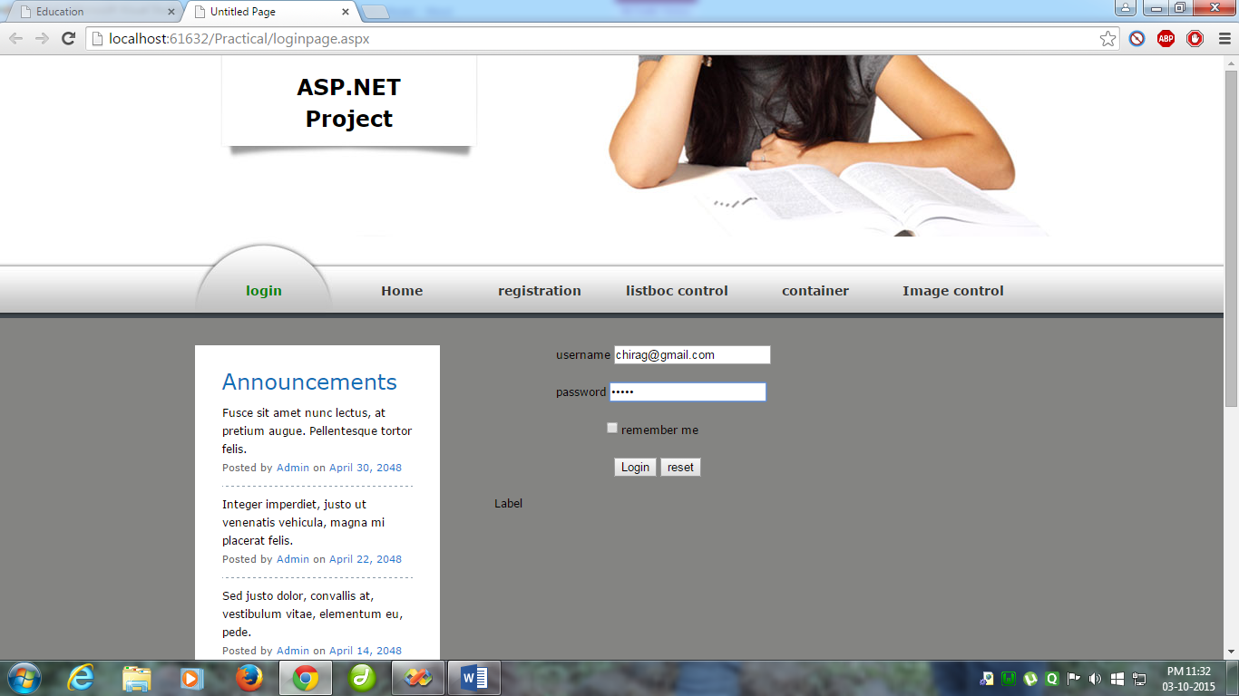

Code behind

<%@PageLanguage="VB"MasterPageFile="~/mymaster.master"AutoEventWireup="false"CodeFile="loginpage.aspx.vb"Inherits="Default3"title="Untitled Page"%>

